User rights for CCH Tagetik

$USER

Tagetik web

User side
The user has access to all the functionalities available in the user side.
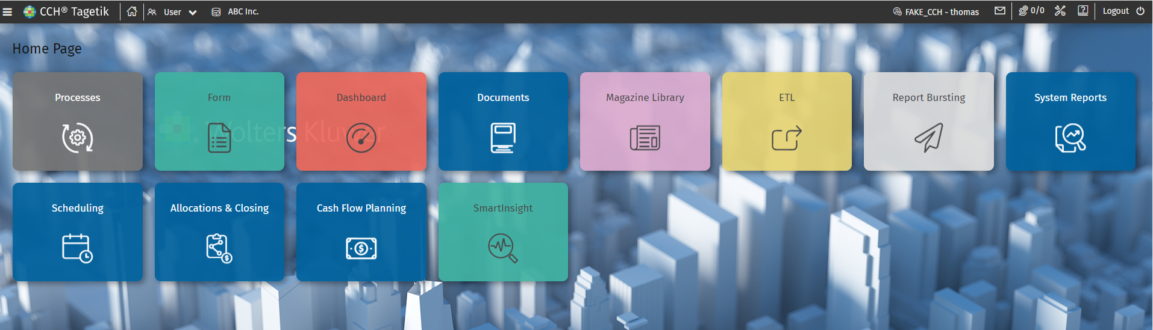
In the process cockpit:
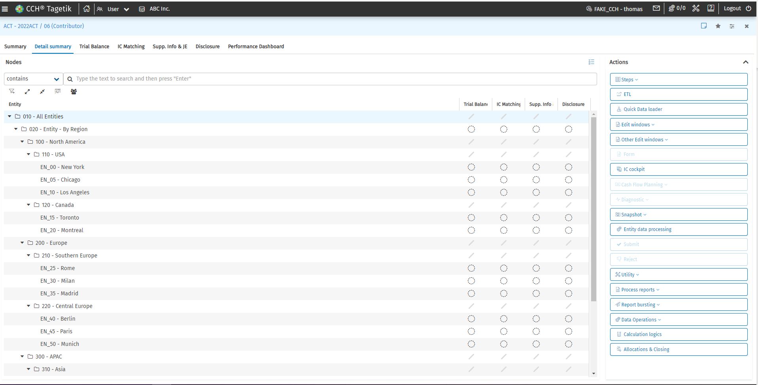
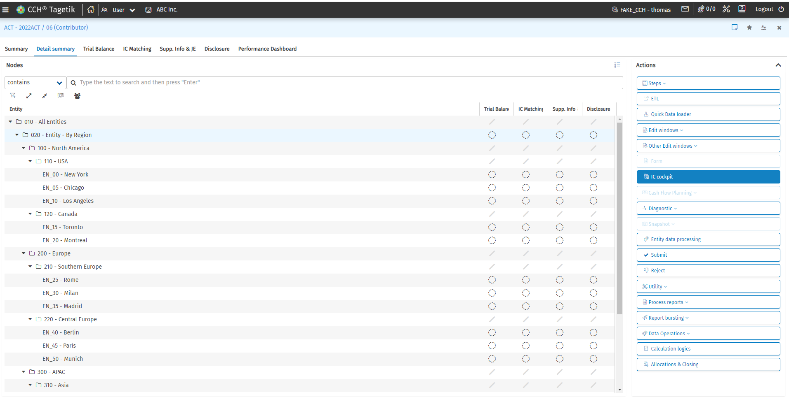
It is important to mention that the user has no access to the consolidation view. However, the user, can run the different steps of the process.
The only way for user to create report, is from the smart insight as the user has no access to the design mode in Excel.
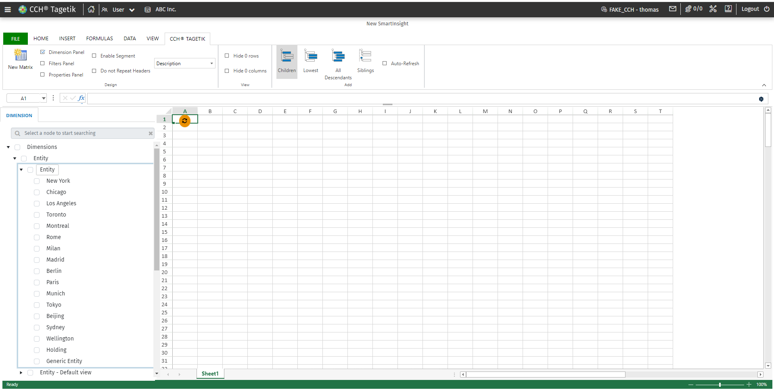

Admin side

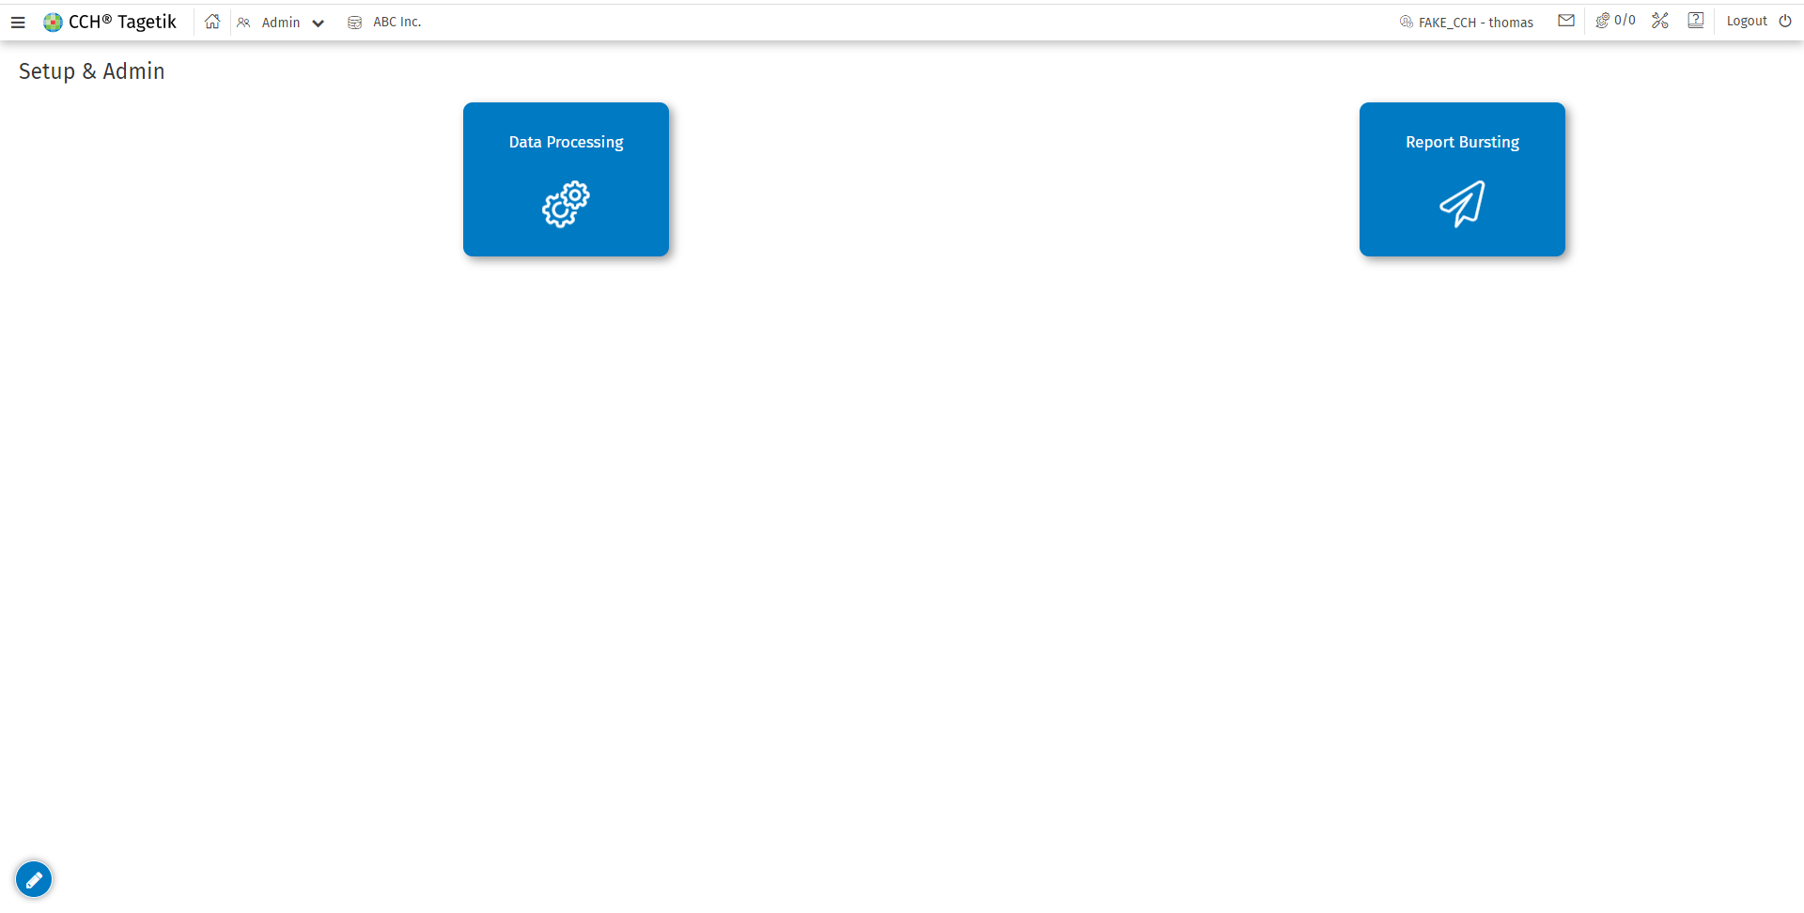
In the Admin side, the only two functionalities that are available are the data processing and the report Bursting.
In the Data processing, the user has access to those functionalities:
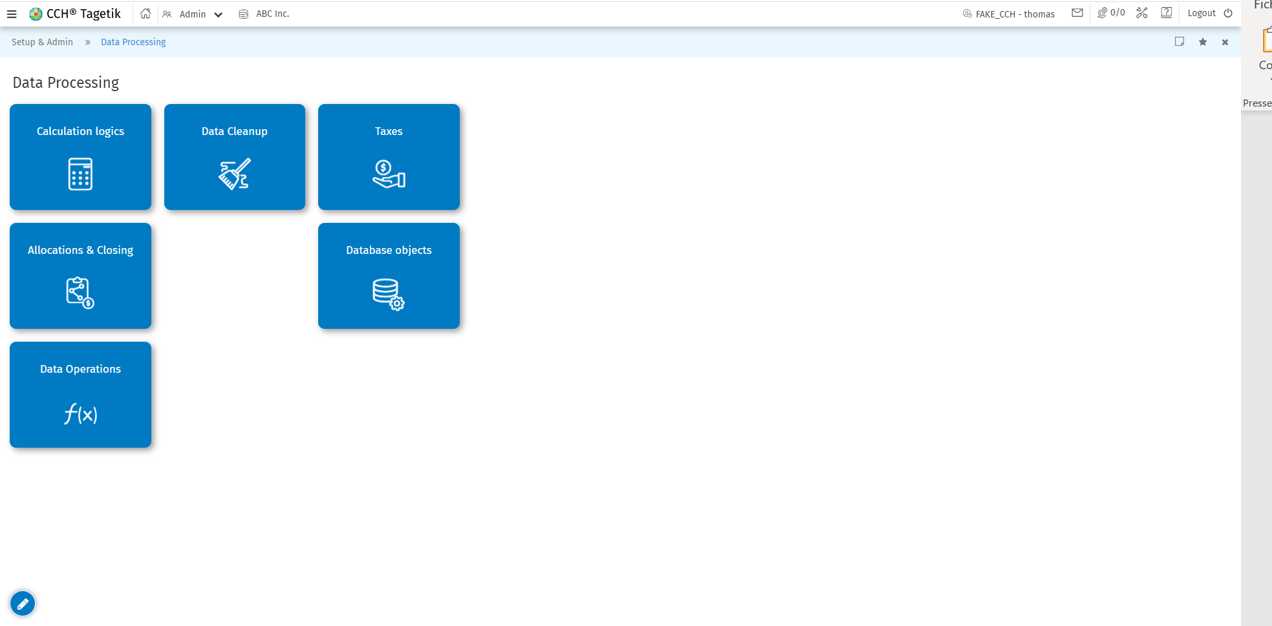
In the admin side, the user has no access to the dimension creation (no creation of account, scenarios, periods,...) but also everything related to the business workflow and process creation.

Excel
The user in Excel has access to the navigation, the data entry form, Ad hoc form and open items tab. However, he has no access to the Design mode, the report list, the parameters definitions, Tagetik style.
In Navigation mode, the user can run the report and has following view :
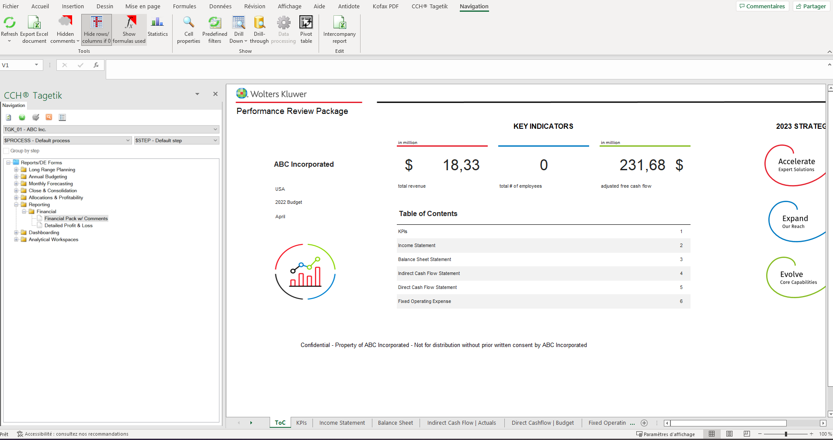

$ALL

Tagetik web

User side
The user has access to all the different tabs available. 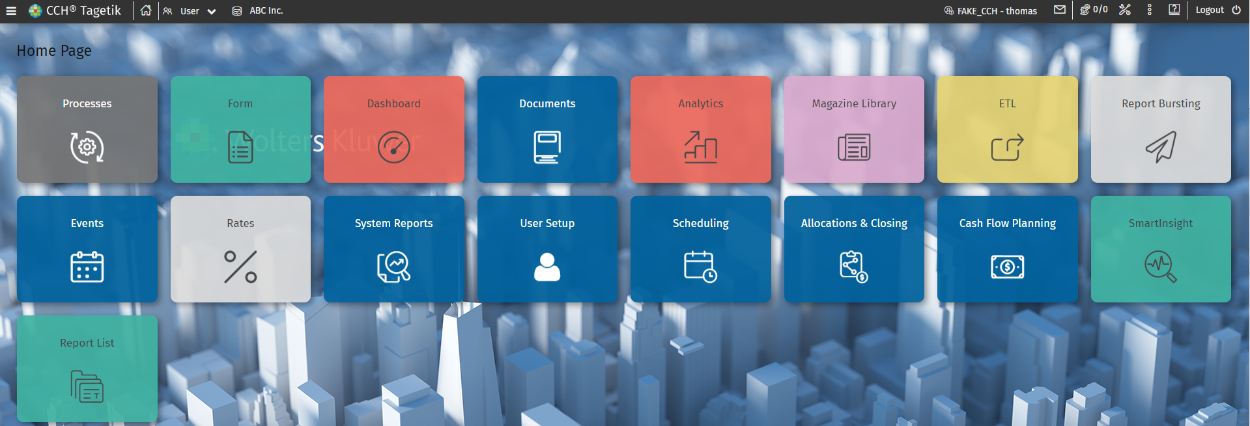
In the process cockpit, the user has access to the consolidator and contributor mode.
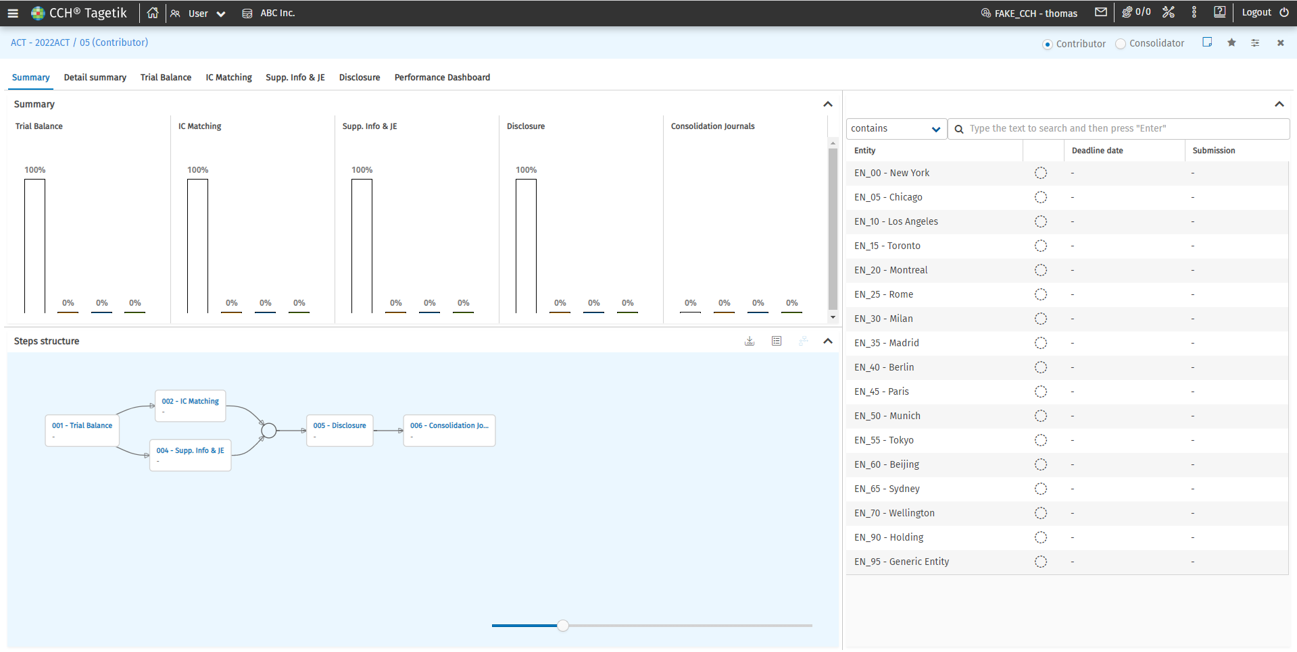
The user can perform all the tasks possible in the process cockpit for the Entities for which he has access.

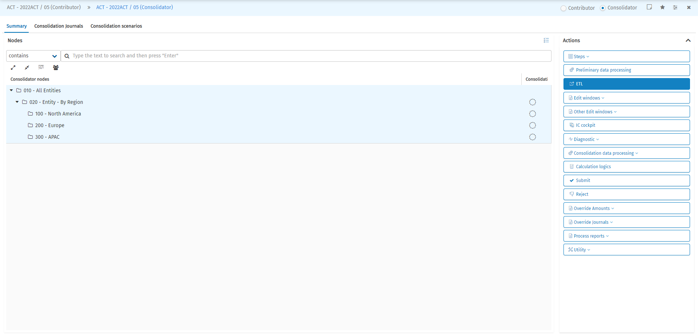

Admin side
The admin has access to the following functionalities:
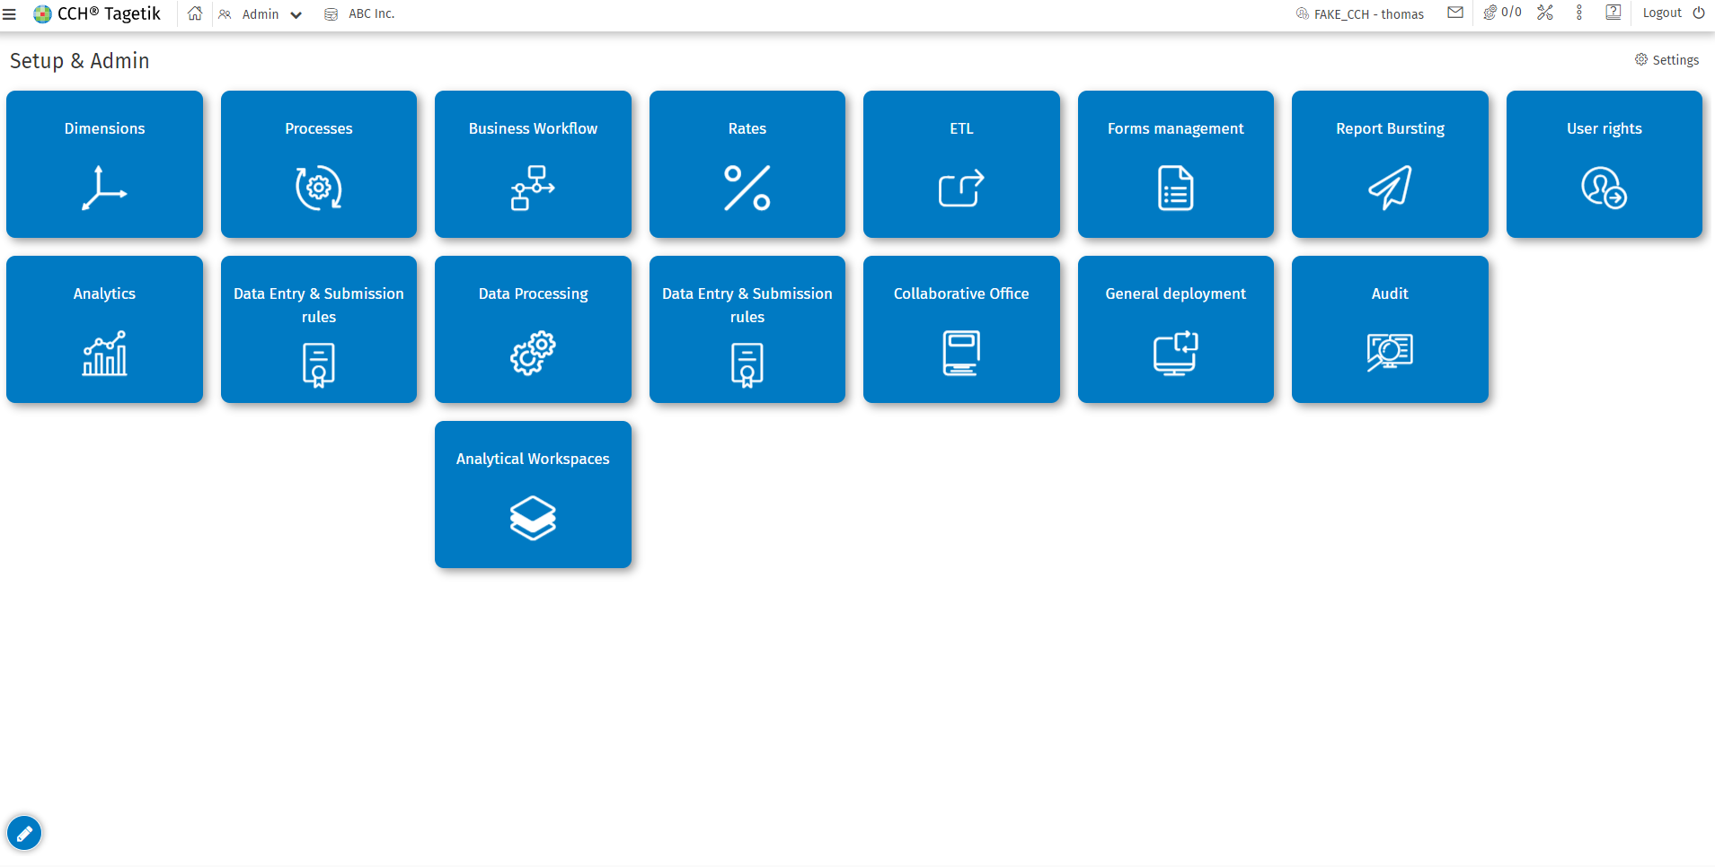

The admin has access to all the functionalities available in admin mode, even to the dimension, business workflow, ETL,..
The admin can also manage the user rights.
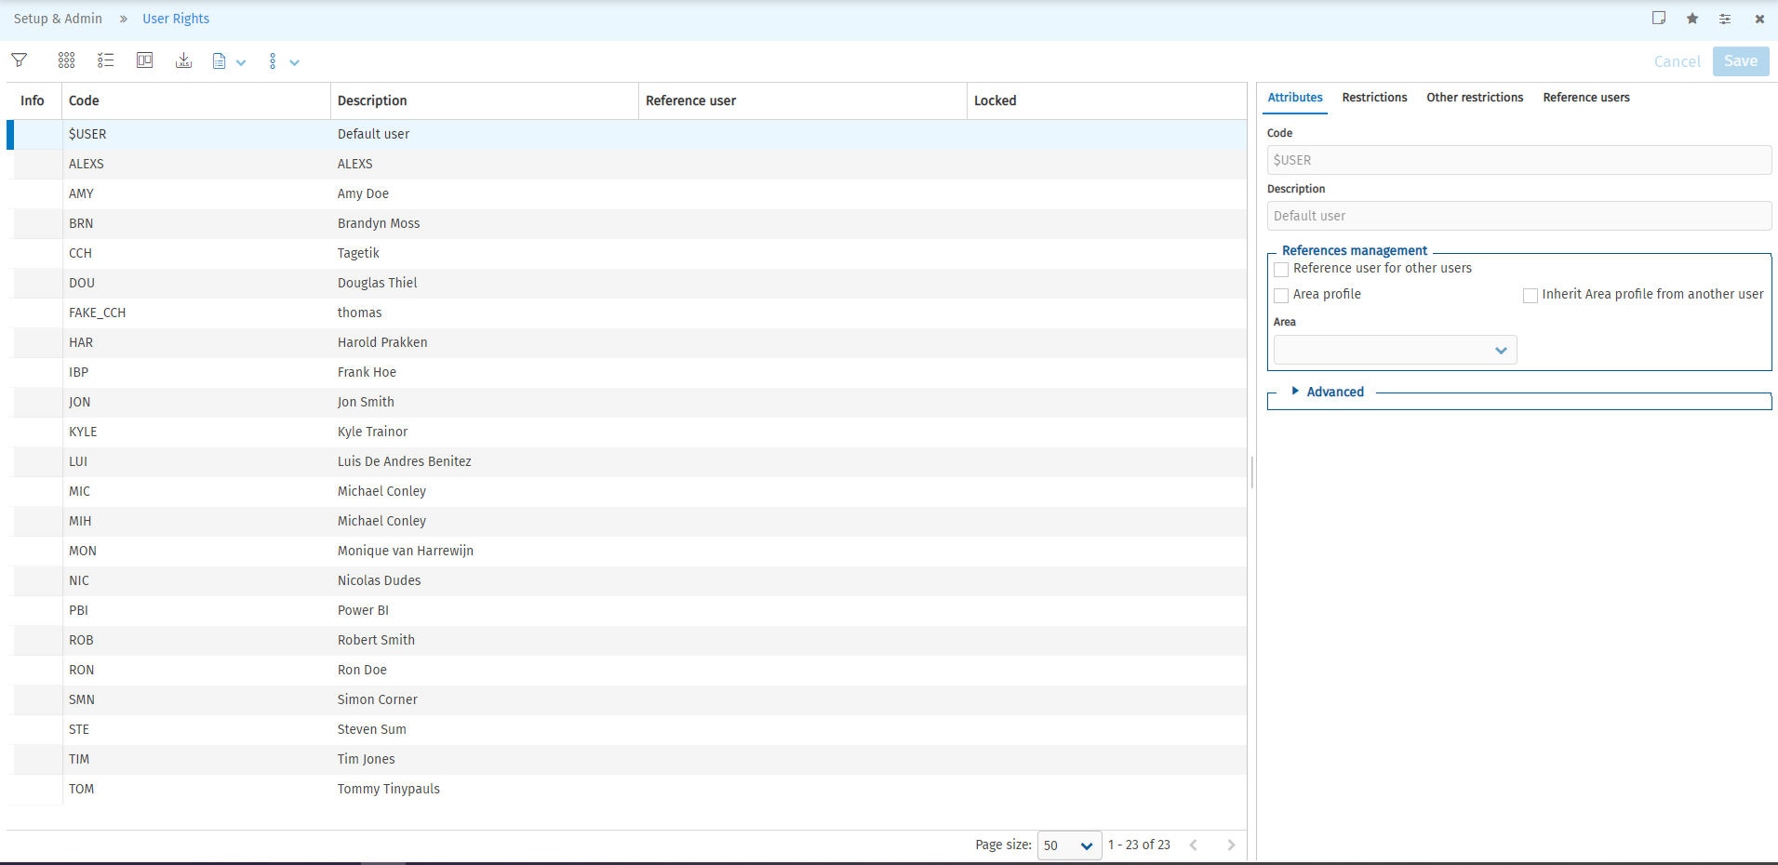
In the ETL, the user can create new ETL and manage the already existing ones. 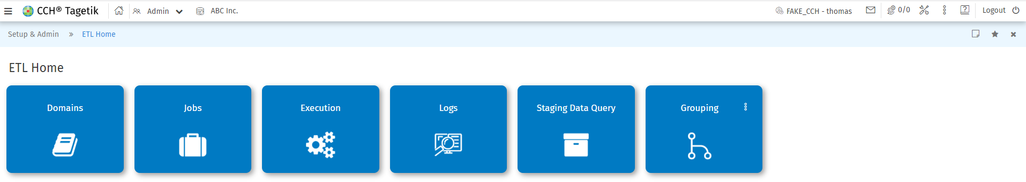
It is important to note that the admin has no access to Query analyzer.

Excel
The user has to all the functionalities available in CCH Tagetik excel add-in ribbon bar.
In Design mode, the user can create a report and run the one already existing. The Tagetik style can be used.
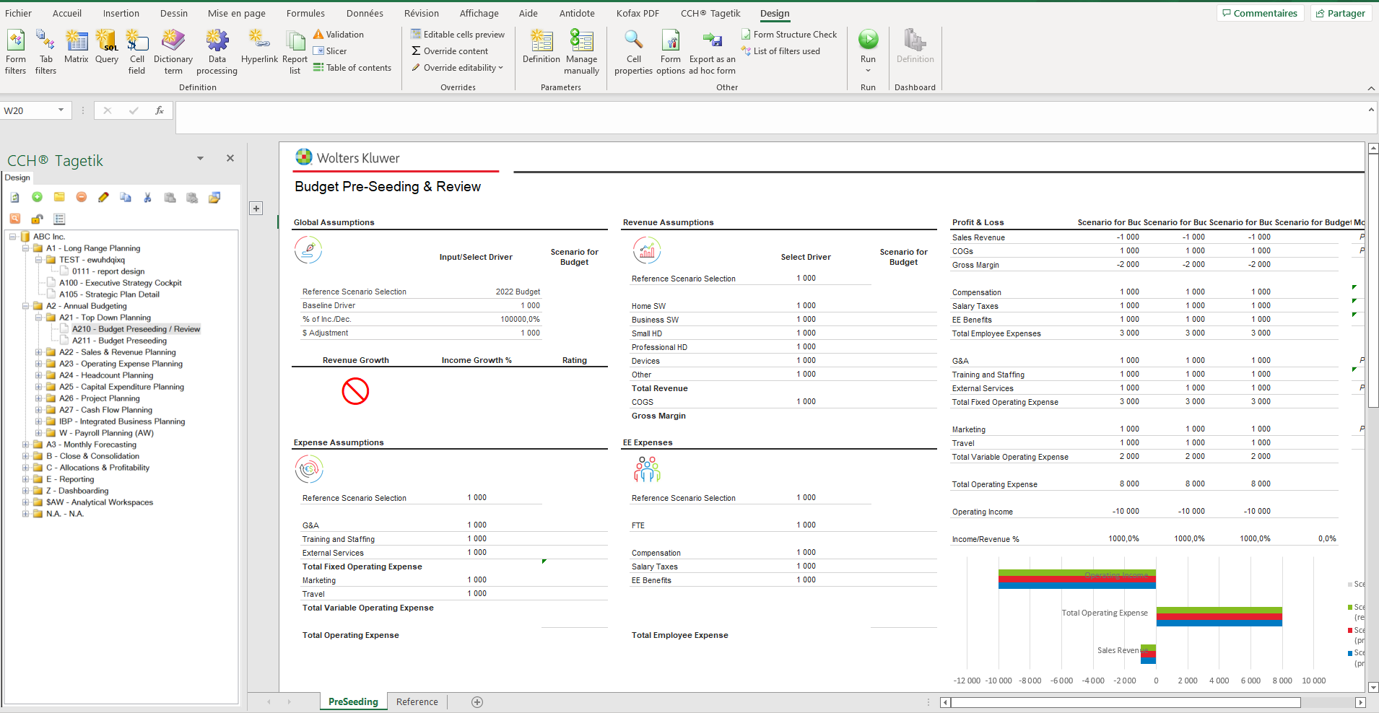
The view in Navigation form is as follow :
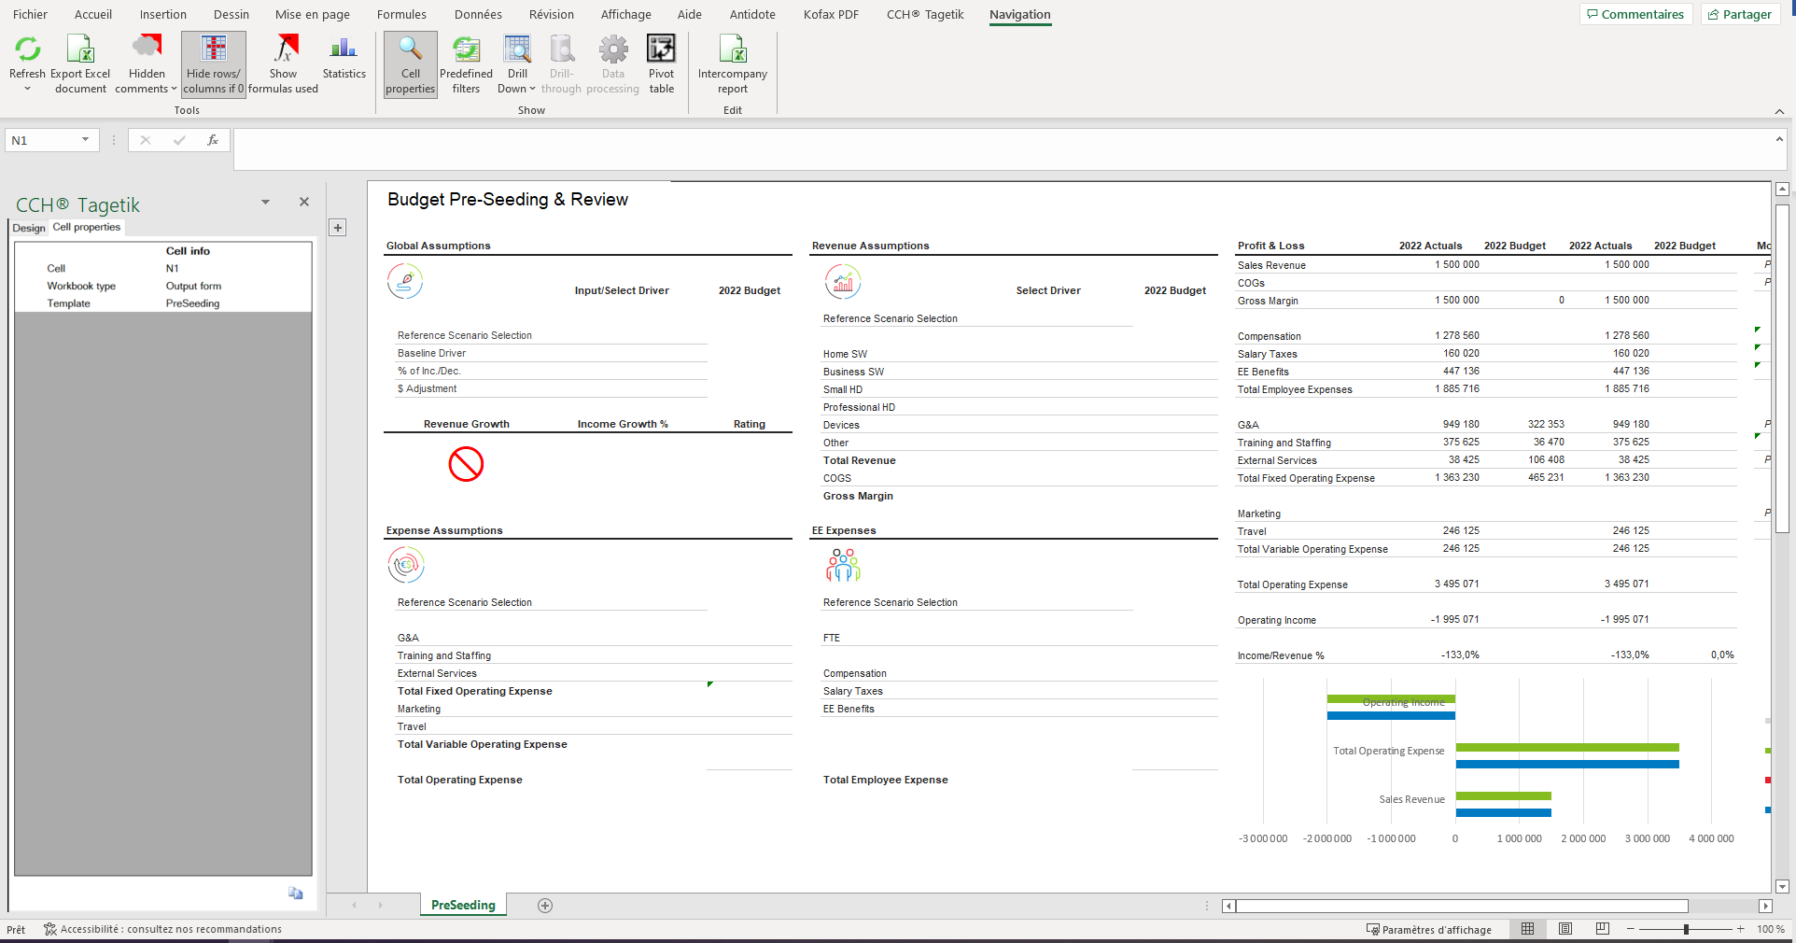

In Data entry form, the user can enter data.

POWERUSER

Tagetik web

User side
The user has access to all the functionalities that are available in the user mode. (Same as $USER).
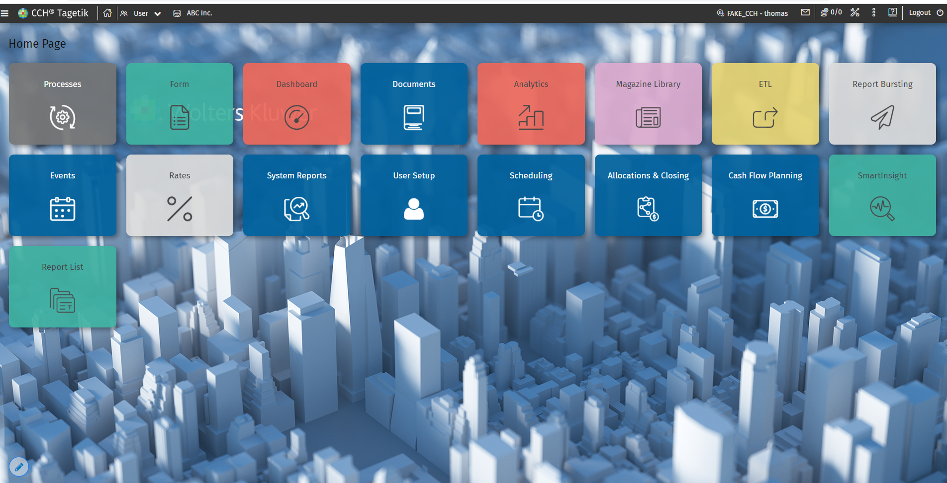

In the process cockpit, the user can execute the different steps of a process. Also, he has access to the contributor and consolidator view. Moreover, he has access to all the actions that are available and unlocked for a particular entity.
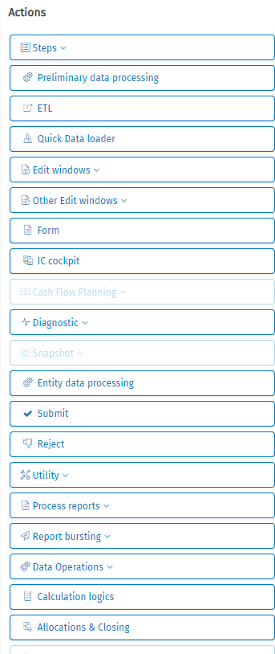
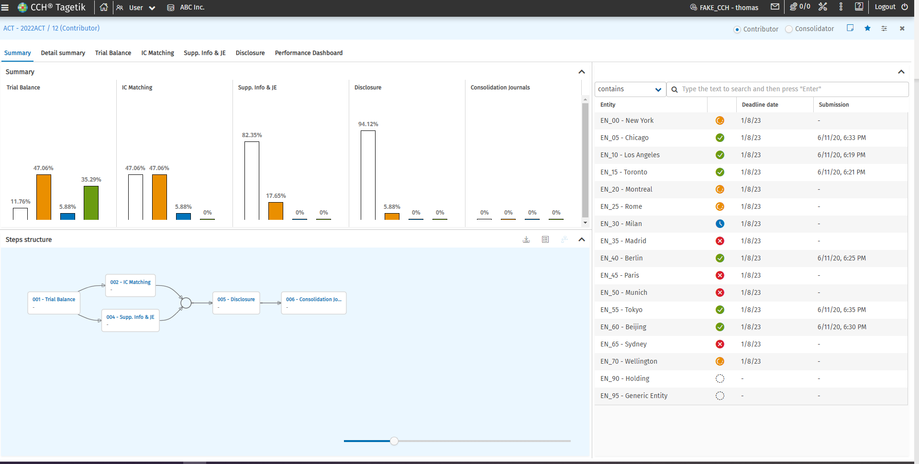
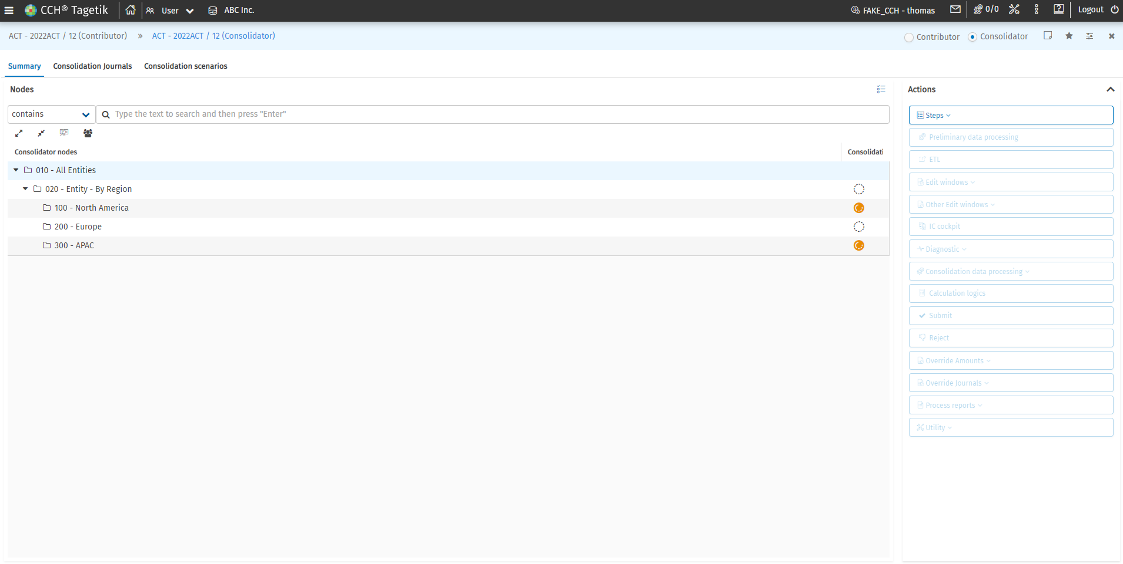

Admin side
The admin as only access to those functionalities.
It is important to note that the admin can’t create/modify any dimension or anything related to it (creation of scenarios, account,…). Also, the user can’t create/modify any process and business workflow.

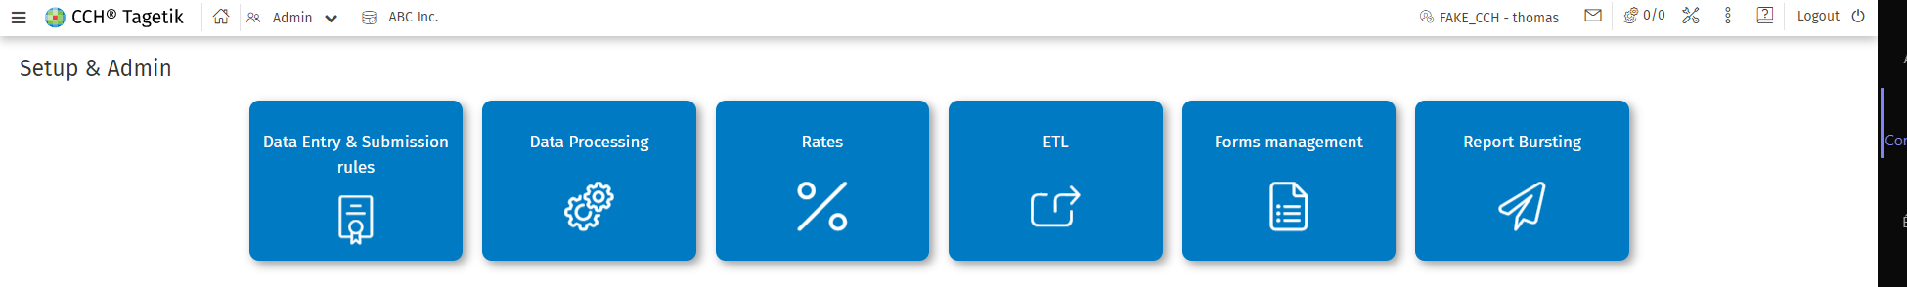

In the ETL functionality, the user cannot create new ETL, he can only execute it.
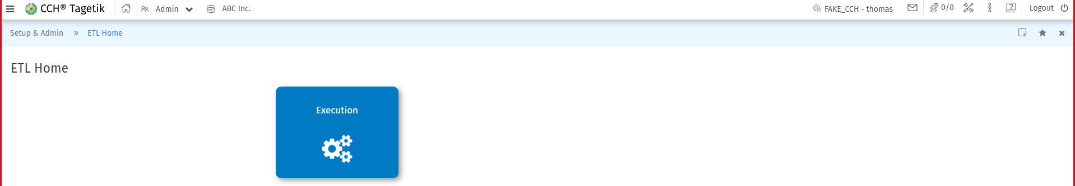

Excel
In the ribbon bar of CCH Tagetik excel add-in, the user has access to all the functionalities available. The user can create report, open them in navigation mode and data entry mode, he has also access to the open items. Moreover, the user can apply and create a Tagetik style but also create a parameter thanks to the parameters definitions.

